

3 Year Strategic Plan (2024/25 – 2027/28)

The SIPR Mission
SIPR’s mission is to support internationally excellent, independent, multi-disciplinary policing research to enable evidence informed policy & practice. The mission statement, aims and core values for SIPR were developed by the Leadership Team and approved by the Executive Committee.

SIPR aims:
- Facilitating internationally excellent, independent research of relevance to policing (RESEARCH);
- Engaging in a range of knowledge exchange activities to strengthen the evidence base on which policy and practice are improved & developed nationally and internationally (KNOWLEDGE EXCHANGE);
- Nurturing a culture of learning & innovation (LEARNING AND INNOVATION); and
- Promoting the development of national & international links with researcher, practitioner and policing communities (PARTNERSHIPS).

3-year plan objectives
Within these four aims we will strive to achieve the following:

RESEARCH
- Supporting internationally excellent policing research under three strategic research themes in order to shape strategic focus and respond to external drivers.
- Enhance excellence of SIPR policing research through improvements to quality assurance processes.

KNOWLEDGE EXCHANGE
- Facilitate events and enhance knowledge exchange tools with international reach.
- Support evidence to practice routes and develop pathways to enable and document impact.

LEARNING AND INNOVATION
- Nurture learning and innovation in policing organisations and universities, supporting the postgraduate community and the next generation of researchers and practitioners.
- Foster links between higher education and policing organisations and partners to support training, education, leadership, and innovation.

PARTNERSHIPS
- Facilitate networking and collaboration between academics, practitioners, and policy makers nationally and internationally.
- Develop strategic links with new and existing partners.

Measuring our successes

Diagram 1, below illustrates how the objectives and activities link together and provides some key measurements to indicate how we will demonstrate success against our set objectives.

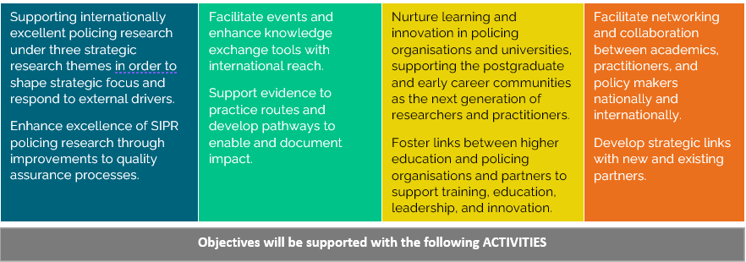
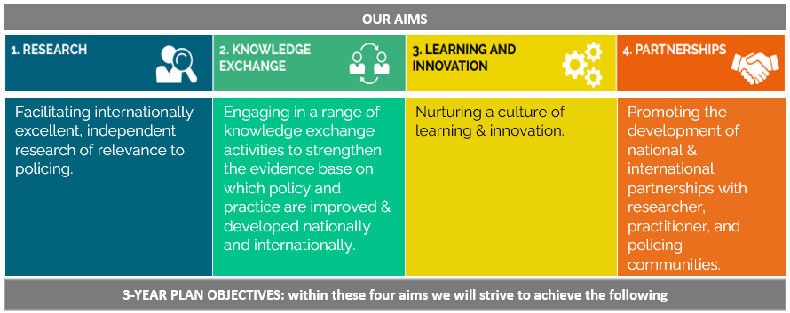
Diagram 1: Strategic Objectives Actions and Measures
